**Assignment ID:** **11_RestFulAPI_Assignment1**

Code:



Add a Book

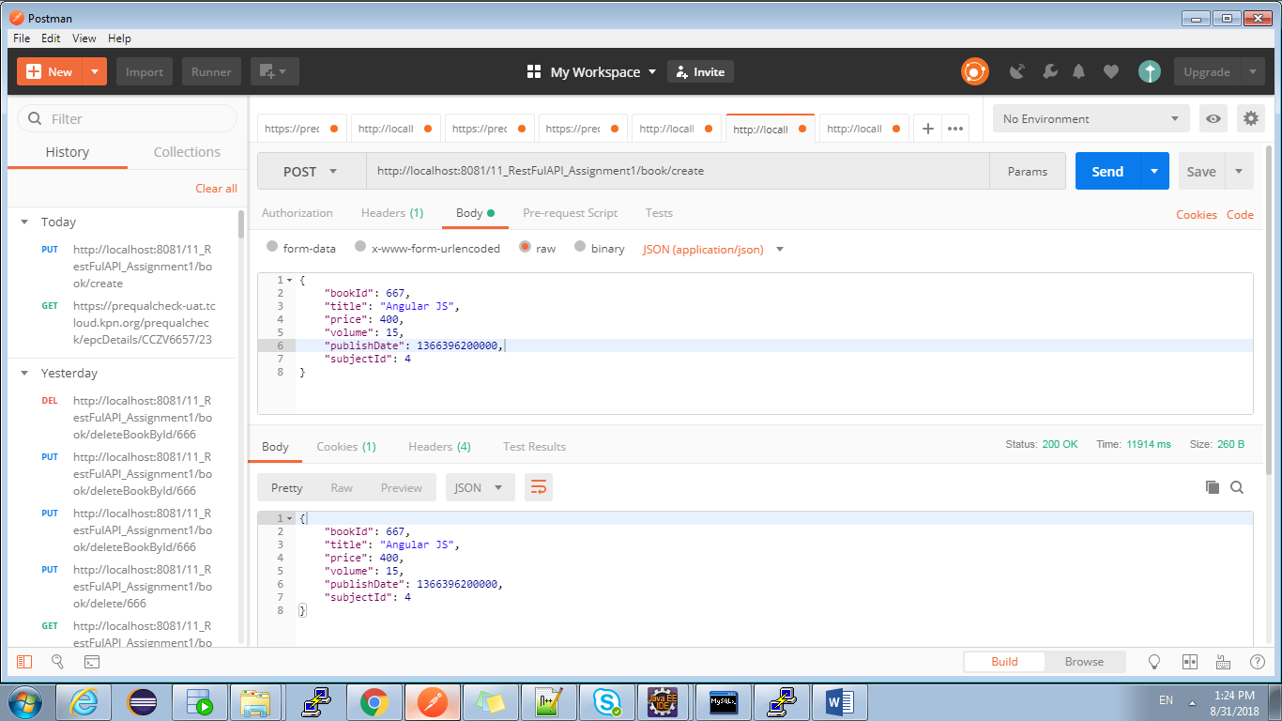

Modify A Book

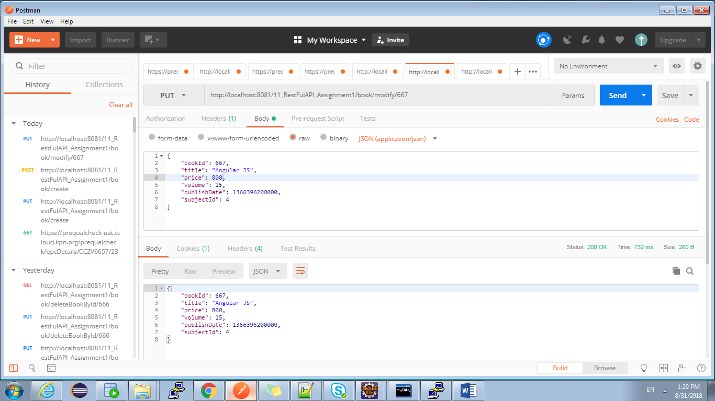

Delete the book

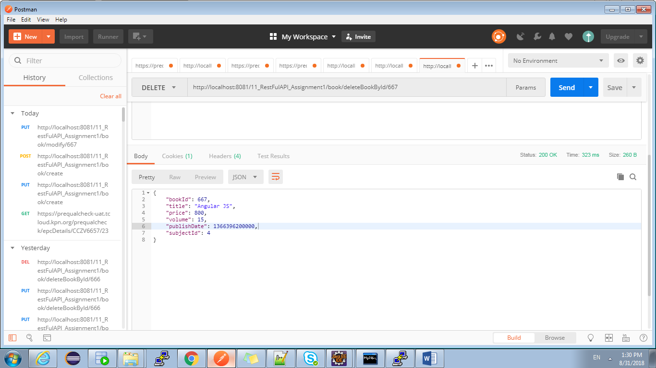

Get A Book By Id

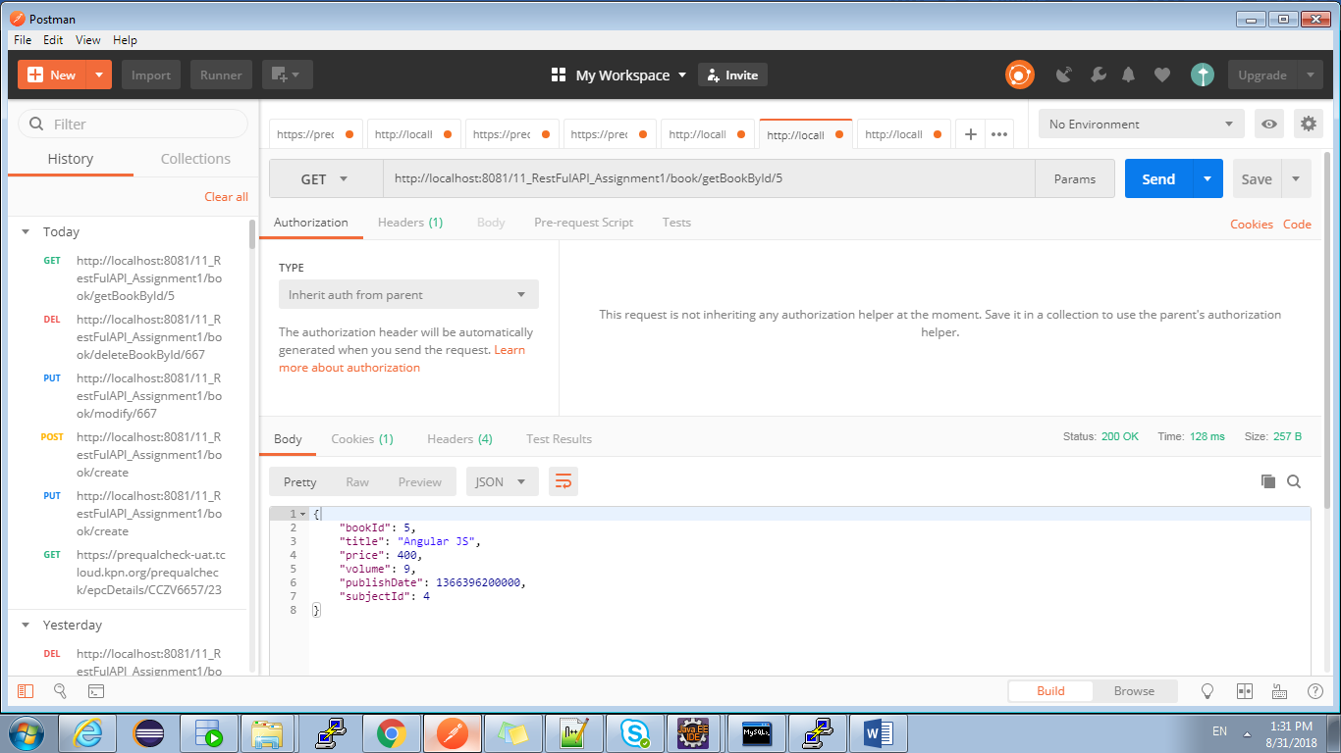

Get All Books

